**Experiment - 2**

**Student Name: Vivek Kumar UID: 21BCS8129**

**Branch: BE-CSE(LEET) Section/Group: WM-20BCS-616/A**

**Semester: 5th Date of Performance: 20/08/2022**

**Subject Name: Project Based Learning in Java Lab Subject Code: 20CSP-321**

**1. Aim/Overview of the practical:**

Design and implement a simple inventory control system for a small video rental store.

**2. Task to be done/ Which logistics used:**

Write the program to design and implement a simple inventory control system for a small video rental store.

**3. Software Requirements (For programming-based labs):**

* JDK-8 or any
* Eclipse-IDE for Java

**4. Steps for experiment/practical/Code:**

package Unit1;

import java.util.Scanner;

class Video {

String videoName;

boolean checkOut;

int rating;

String getName()

{

return videoName;

}

void doCheckOut()

{

checkOut = true;

}

void doReturn()

{

checkOut = false;

}

void receiveRating(int rating)

{

this.rating = rating;

}

int getRating()

{

return rating;

}

boolean getCheckOut()

{

return checkOut;

}

public Video(String videoName)

{

this.videoName = videoName;

}

}

class VideoStore {

Video store[]= new Video[20];

static int a=0;

void addVideo(String name)

{

store[a] = new Video(name);

store[a].checkOut = false;

store[a].receiveRating(0);

System.out.println("video " +name +" added sucessfully");

a++;

}

void doCheckOut(String name)

{

for(int i=0; i<a;i++)

{

if(store[i].getName().equals(name))

{

store[i].doCheckOut();

System.out.println("Video " +name +" removed successfully from "+i +" location");

}else {

System.out.println("No such video exists at:" +i+" location");

}

}

}

void doReturn(String name)

{

for(int i= 0; i<a;i++)

{

if(store[i].getName().equals(name))

{

store[i].doReturn();

System.out.println("Video returned: " +name +" from location "+i);

}else{

System.out.println("No such video exists at locations:" +i);

} } }

void receiveRating(String name, int rating)

{

for(int i= 0; i<a;i++)

{

if(store[i].getName().equals(name))

{

store[i].receiveRating(rating);

}

}

System.out.println("Ratings " +rating +" has been mapped to the video " +name);

}

void listInventory()

{

for(int i= 0; i<a;i++)

{

if(!store[i].getCheckOut())

{

System.out.print("Videos (location "+i+ "): "+store[i].videoName+" Ratings (location "+i+ "): "+store[i].getRating()+"\n");

}}

}

public void exit() {

System.exit(0);

}

}

class VideoStoreLauncher {

public static void main(String[] args) {

VideoStore obj = new VideoStore();

int choice;

String videoName;

int rating;

boolean status = true;

while(status)

{

System.out.println("MAIN MENU");

System.out.println("*********");

System.out.println("1.Add Videos:");

System.out.println("2.Check Out Videos:");

System.out.println("3.Return Videos:");

System.out.println("4.Receive Rating:");

System.out.println("5.List Inventory:");

System.out.println("6.Exit");

System.out.println("Enter your choice:");

Scanner sc = new Scanner(System.in);

choice = sc.nextInt();

switch(choice)

{

case 1:

{

System.out.println("Enter the name of the video you want to add");

videoName = sc.next();

obj.addVideo(videoName);

break;

}

case 2:

{

System.out.println("Enter the name of video to checkout");

videoName = sc.next();

obj.doCheckOut(videoName);

break;

}

case 3:

{

System.out.println("Enter the video name to return");

videoName = sc.next();

obj.doReturn(videoName);

break;

}

case 4:

{

System.out.println("Enter the name of video you want to rate");

videoName = sc.next();

System.out.println("Enter the Ratings for this video");

rating = sc.nextInt();

obj.receiveRating(videoName, rating);

break;

}

case 5:

{

obj.listInventory();

break;

}

case 6:

{System.out.println("Exiting...!! Thanks for using the application");

obj.exit();

break;

}

default:

{

System.out.println("Wrong input!!");

}

}

}

}

}

**5. Observations/Discussions/ Complexity Analysis:**

Here we have created the VideoStoreLauncher, VideoStore and Video and I have Passed all the Parameters according to the Requirement given in the question.

**6. Result/Output/Writing Summary:**

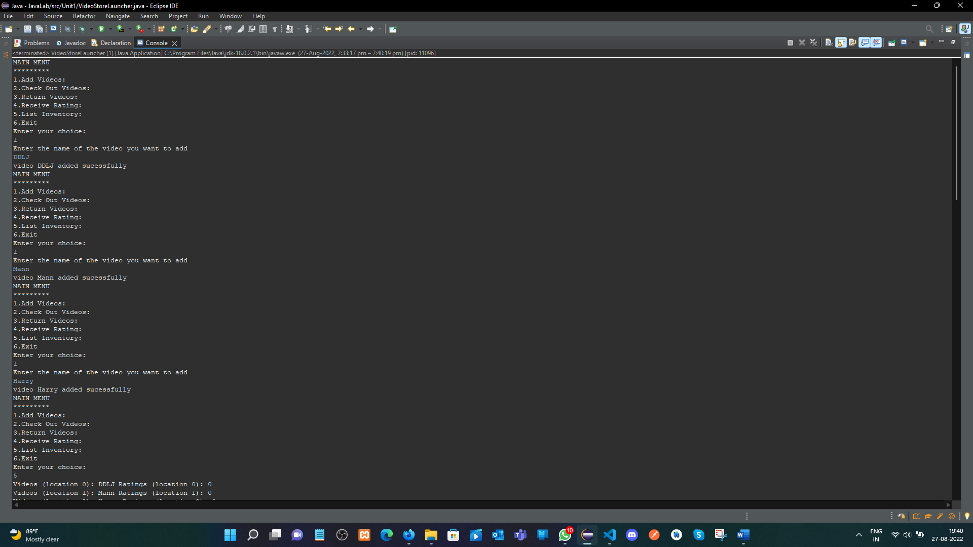

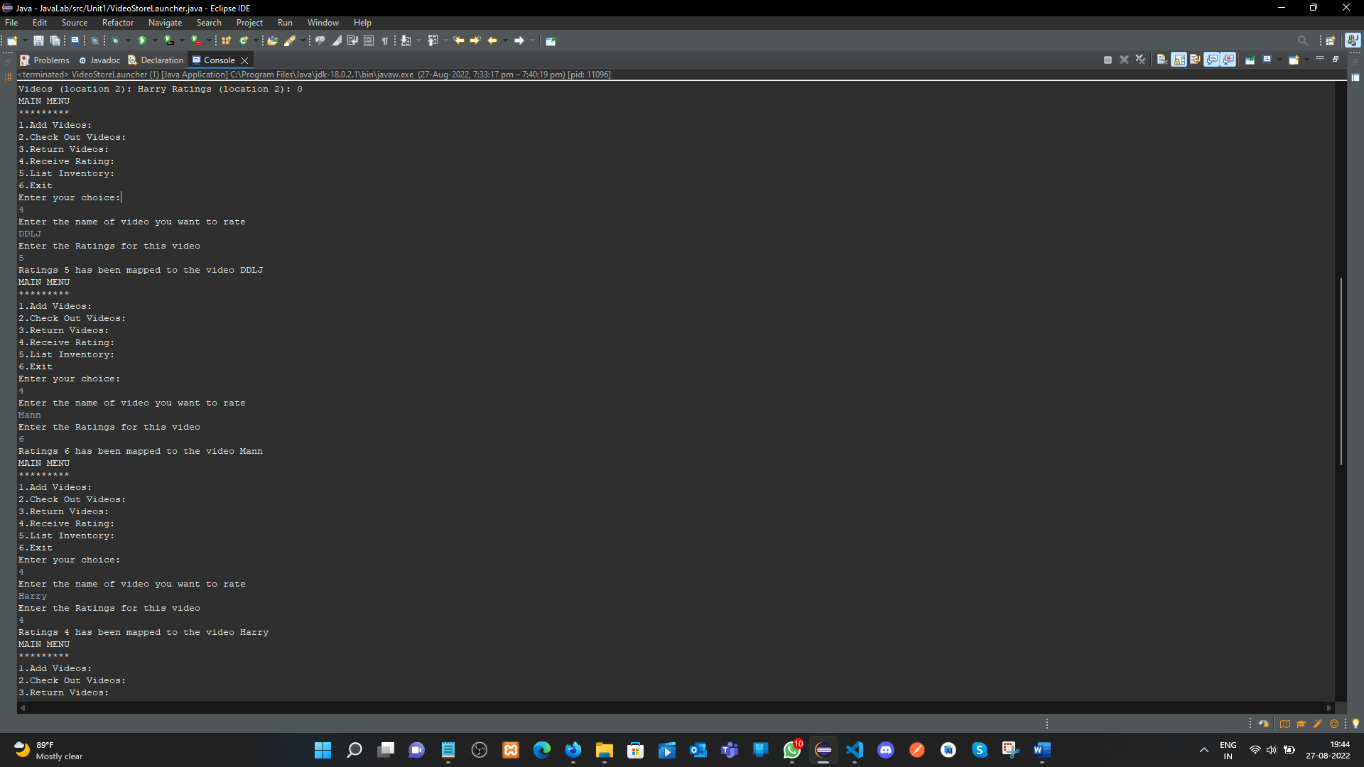

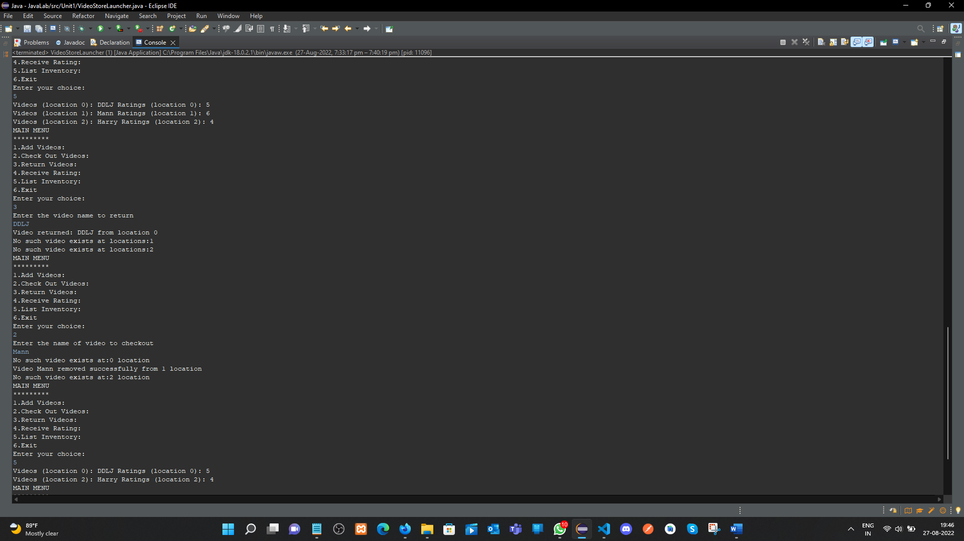

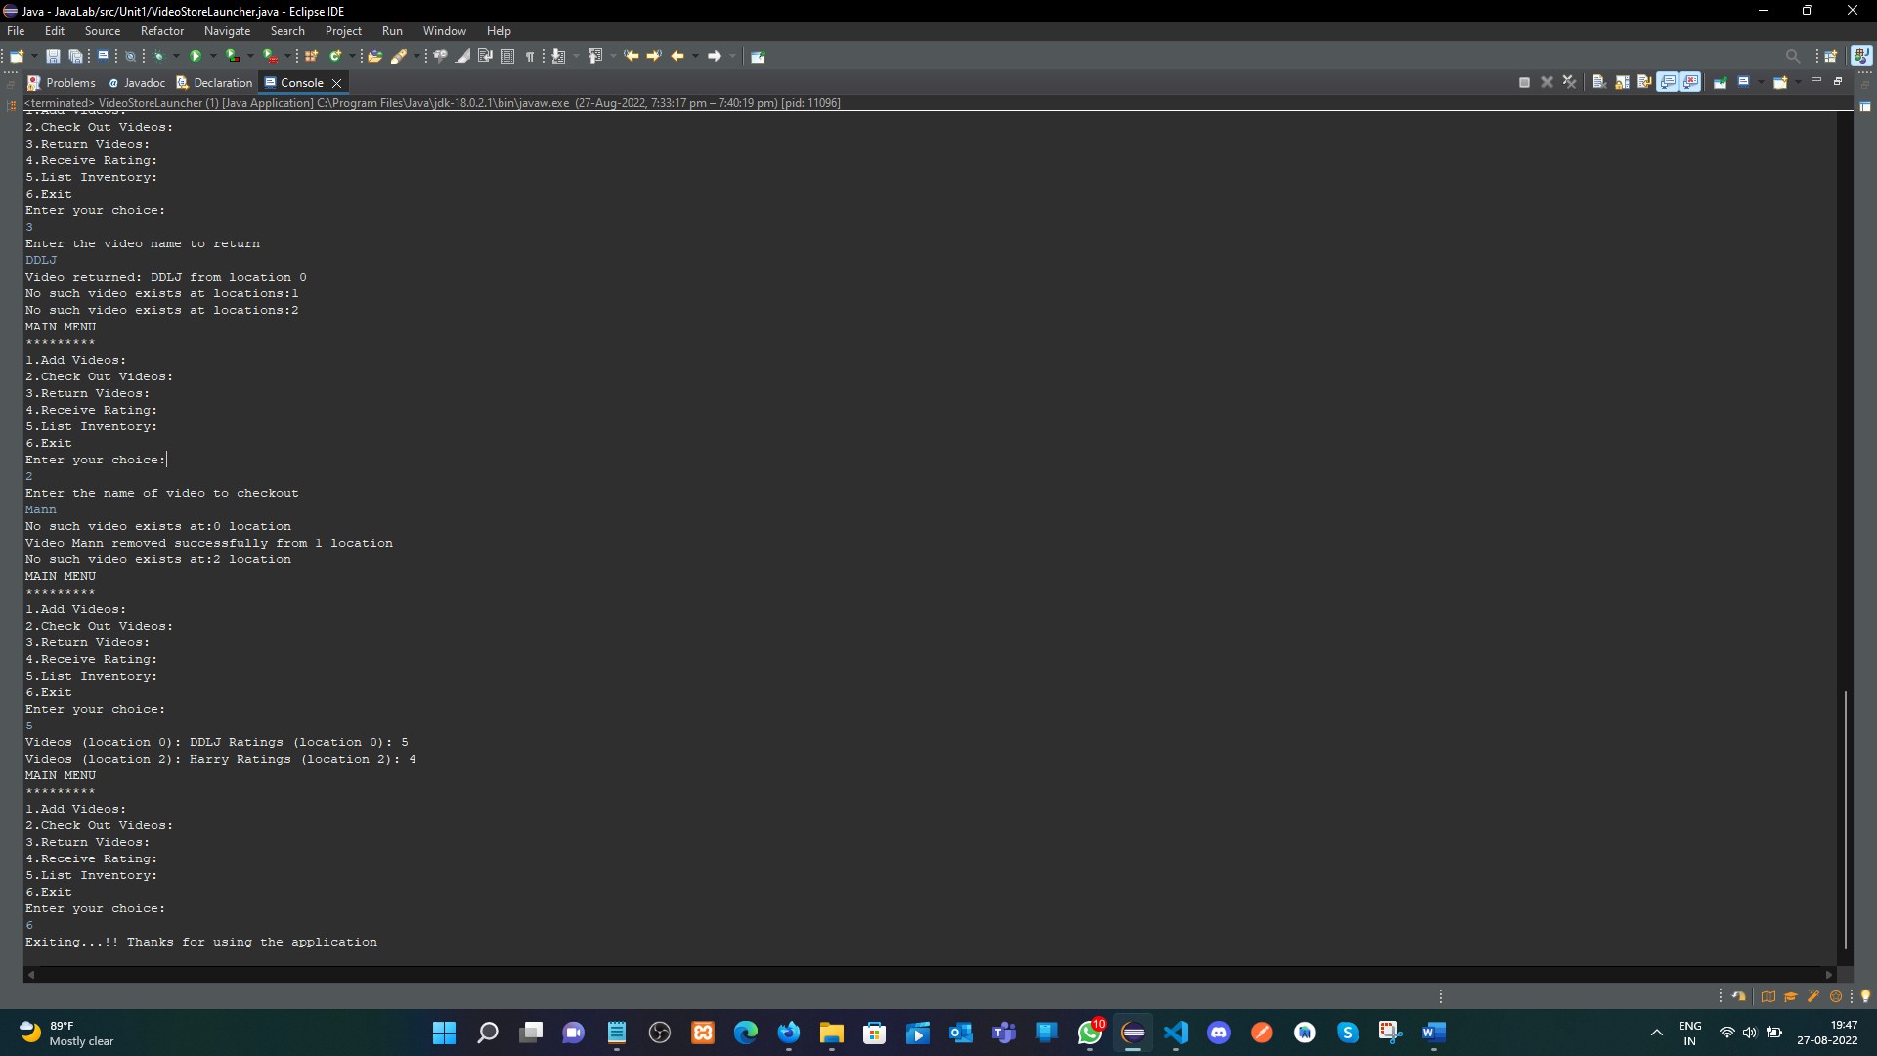

**Learning outcomes (What I have learnt):**

**1.** Learn How use the inheritance concept.

**2.** java classes and all the features.

**Evaluation Grid (To be created as per the SOP and Assessment guidelines by the faculty):**

|  |  |  |  |
| --- | --- | --- | --- |
| Sr. No. | Parameters | Marks Obtained | Maximum Marks |
| 1. |  |  |  |
| 2. |  |  |  |
| 3. |  |  |  |
|  |  |  |  |